
Braywood C of E Nursery
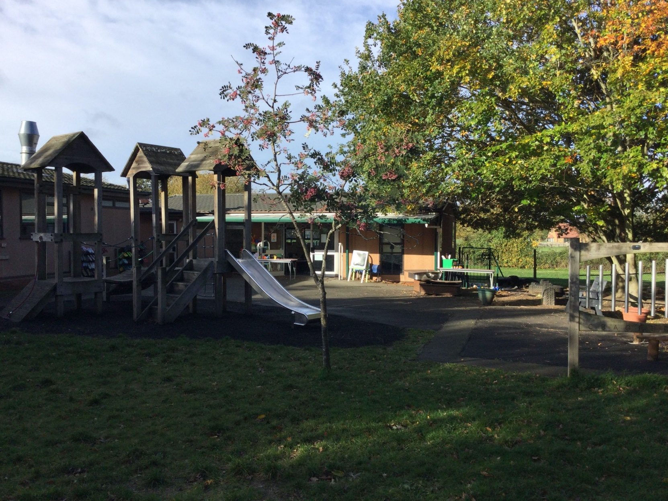

‘From tiny acorns’ mighty oak trees grow, watered and nurtured by God’s love’

Growing and Learning Together

Welcome to Our Acorn Nursery

At Acorn Nursery the children learn through play in a happy stimulating and safe environment and we support the children in becoming confident, independent and inquisitive learners. As part of a Church of England school, our fundamental Christian ethos ensures that everyone feels that they belong and we welcome all families of all faiths and of no faiths.

Our Learning

The first five years of a child’s life are of vital importance. A child’s experience and learning during these years is the foundation for the learning and development during the rest of their life.
In the nursery, children learn through playing and exploring; they will be involved in rich stimulating activities with appropriate resources that help to develop the ‘whole child’.
Children will have the opportunity to choose some of their own activities: children will learn much more easily if they enjoy the activities they are involved in. It is the adult’s role to facilitate and extend this learning through quality interactions during the child’s play.
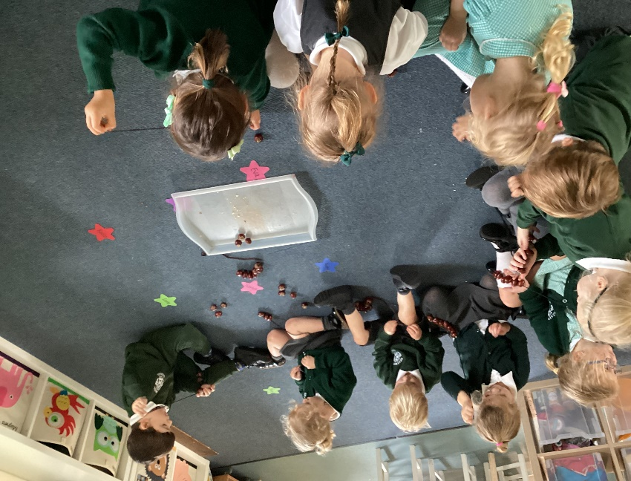
The children will also have short sessions throughout the day where they will sing songs, listen to stories, sing number rhymes and develop their counting skills.
The children spend time talking together and listening to each other to develop their communication skills and learn from each other. Regular updates and photographs will be readily available through ‘FAMLY’, our electronic communication system.

Our Nursery Curriculum

The Early Years Foundation Stage (EYFS) sets the standards that all early years’ providers must meet to ensure that children learn and develop well and are kept healthy and safe. It gives children the broad range of knowledge and skills that provide the foundation for good future progress throughout their school life and beyond. This encompasses the Nursery and Reception Years.

Four guiding principles shape practice in the early years’ settings. These are:

- Every child is a unique child, who is constantly learning and can be resilient, capable, confident and self-assured;
- Children learn to be strong and independent through positive relationships
- Children learn and develop well in enabling environments, in which their experiences respond to their individual needs and there is a strong partnership between practitioners and parents/carers;
- Children develop and learn in different ways and at different rates. The framework covers the education and care of all children in early years’ provision, including children with special education needs and disabilities.

Our curriculum objectives are taken from the Development Matters document. Development Matters - GOV.UK (www.gov.uk)
These are used to plan our learning and to ensure our inside and outside environment are carefully arranged with bespoke resources available to meet the needs of each child. Activities are planned which divides the children’s learning into

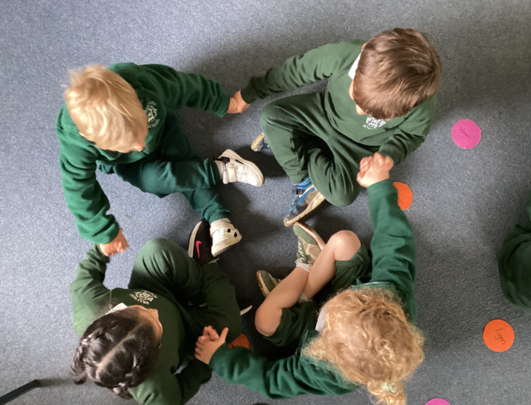
Three Prime Areas:

Communication and Language
Physical Development
Personal, social and Emotional Development

Four Specific Areas:

Literacy;
Mathematics;
Understanding the World;
Expressive Arts and Design.

Our Nursery Environment

In our Acorn Nursery we believe that children learn best when they are engaged, stimulated, motivated and happy. We aim to foster a love of learning by supporting the children’s interests through first hand experiences that enable the children to learn about themselves, others and the world around them. Our Nursery building is separate from the main First School building but we share the use of our wonderful outdoor area (including a forest area and trim trail) with our Reception class. Our catering provider, Caterlink, offer a healthy, warm meal cooked on site or a packed lunch but children can bring their own packed lunch if you would prefer.

Settling In
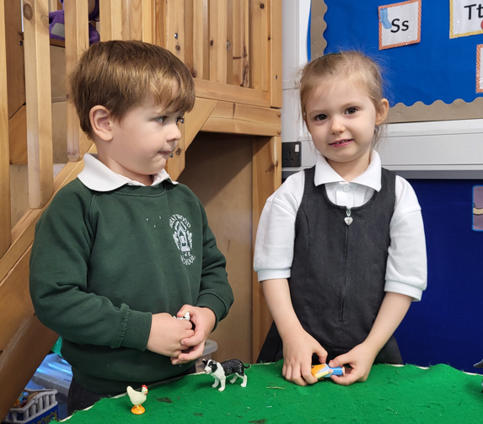
Your child’s first few days and weeks in nursery are really important and we want to ensure they settle in as quickly and happily as possible. Nursery may seem a busy, bustling place which may be bewildering to little ones. To help this process, we offer two induction sessions. The first meeting is with the parents and child so that we can get to know more about your child and their needs. The second is for your child to explore the nursery without their parents; this session will only last 1 ½ hours. Each child has a ‘key worker’ to ensure their needs are addressed.

Start and Finish Times

Our Acorn Nursery session times are as follows:

A whole day session from 8.45am – 3.15pm - 6 ½ hours for £45.00
A half-day session from 8.45am -11.45am – 3 hours for £21.00
Children can join our Nursery after their third birthday. We do accept the 15 or 30 free nursery credits which come into effect the term after your child turns three.

To support our working families, additional facilities are available to our Nursery children. These are paid at the school’s rate:

- Early Birds (breakfast club): 7.45am
- Squirrel Club (after school club): 3.15pm to 5.30pm (4.15pm on Fridays)
- Kiss and Drop: 8.15am
- Grab and Go: end of the school day

Admission Criteria

Our school will decide on the admission criteria for our nursery as an independent, fee-paying nursery according to our school’s policies and procedures. The numbers and ages of children admitted to the nursery comply with the legal space requirements set out in the Early Years Foundation Stage.

We take the following matters into account when prioritising and deciding on admissions.

- Availability of places, staff: child ratios, the age of the child and any registration requirements
- Children who have siblings who are already with us
- When the application is received (extra weight is given to those who have been on the waiting list the longest)
- The nursery's ability to provide the facilities necessary for the welfare of the child, including appropriate staffing arrangements
- A child requiring a full-time place may have preference over one requiring a part-time place.
- Any extenuating circumstances affecting the child's welfare or the welfare of his/her family.
We operate an inclusion and equality policy and ensure that all children have access to nursery places and services irrespective of their gender, race, disability, religion or belief or sexual orientation of parents.

Admission Forms

Our school asks parents to fill in two forms:

- An admissions’ form for the school so that we have contact details, medical information etc.
- The LEA form so that they can ensure you are able to credit parents for the 15 or 30 nursery entitlement. When filling this form in our setting is called Braywood Acorn Nursery and our URN is 2698015.
- There is a deposit of £50 to secure the place. More information can be found on our website.

