**Epay**

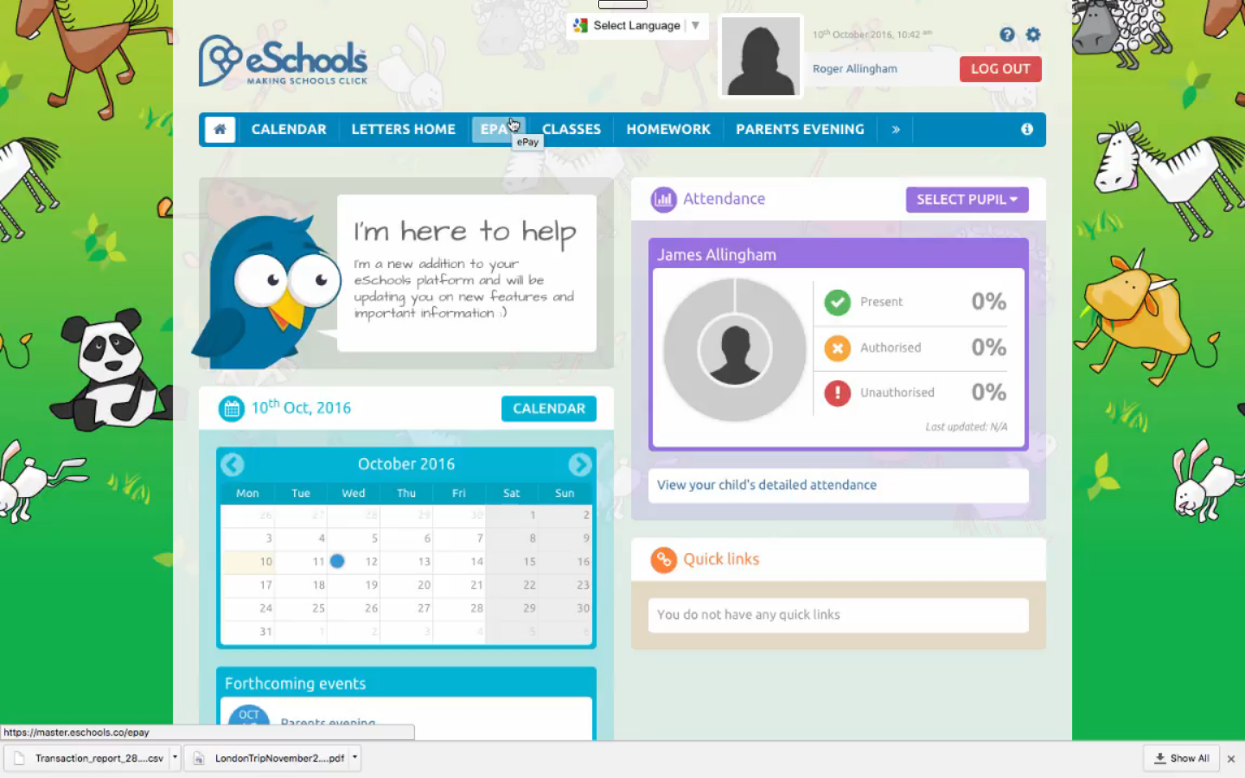

Click to enter payment area.

You will be taken to this screen that lists all payments pending.

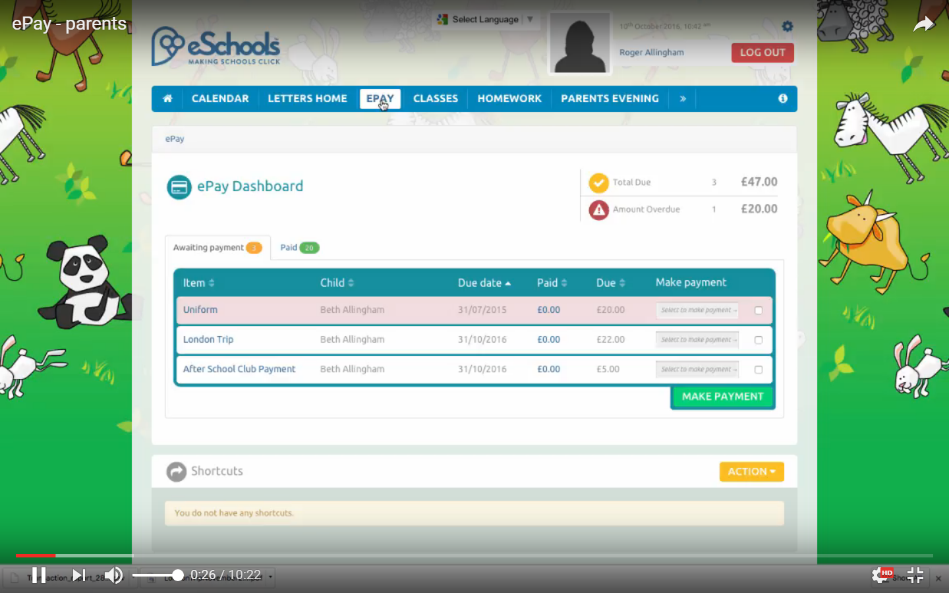

This alert shows £20 is late.

The pink colour shows the payment that is late.

Click to see payments made.

These show on a new page.

These two payments are due on the dates showing.

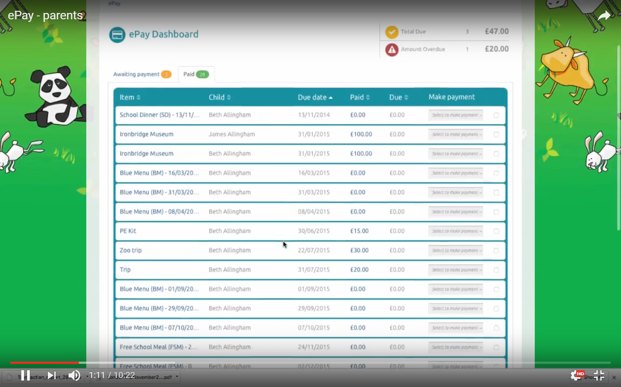

To make a payment. Tick the payment you wish to make on the Awaiting payment and click on Make Payment button.

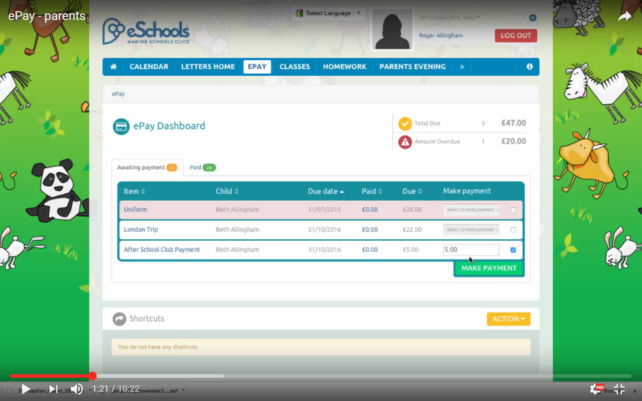

Tick to select the payment you wish to process.

Select the Awaiting payment tab.

Click Make Payments button

You will need to have a Paypal account –

*please note you will be able to pay by credit card a few times and log on as a guest however ultimately you will need to set up a proper PayPal account.*

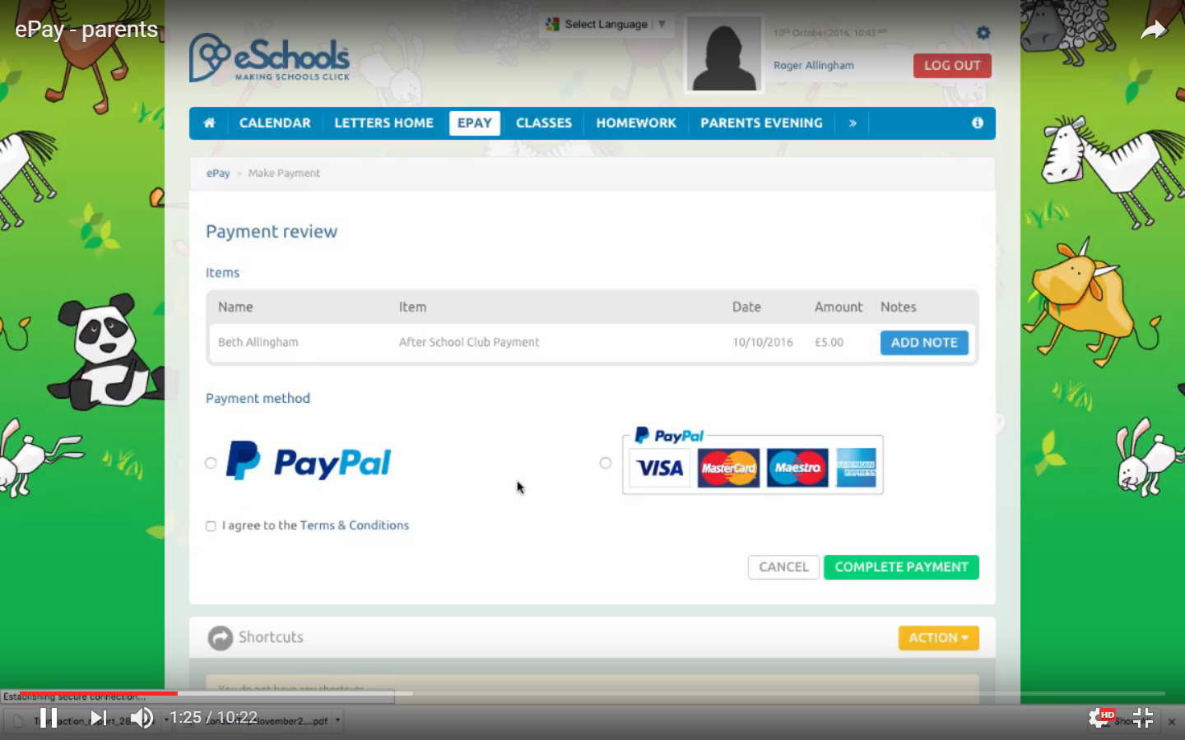

*NB. you can only pay by credit card a few times*

Click on complete payment button.

Either PayPal

Or Credit card

Choose your payment method

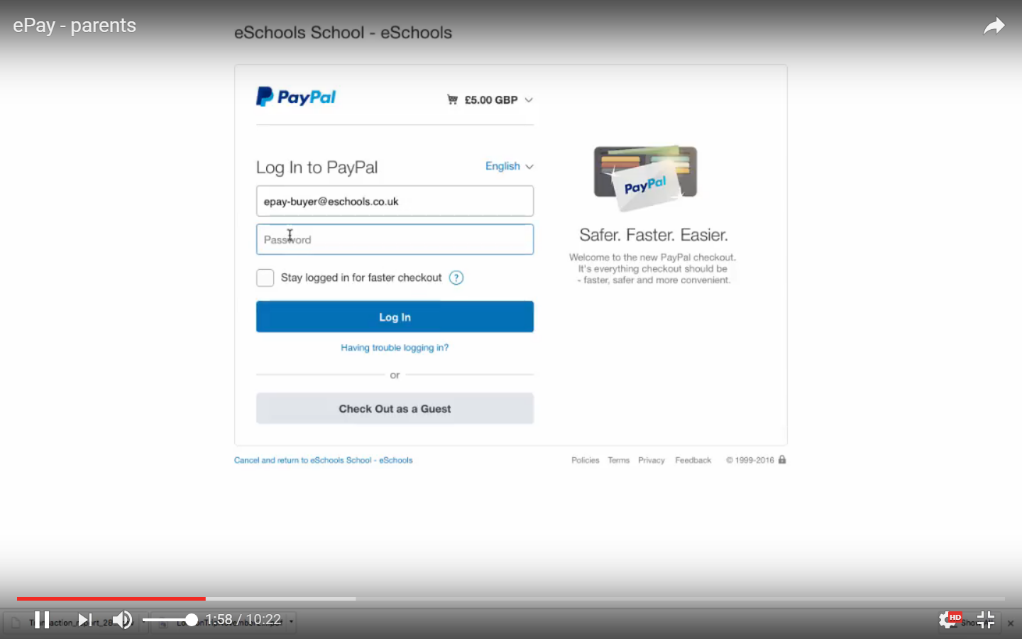

Or as a guest.

Log in with your normal PayPal account details.

This launches Eschool’s PayPal page.

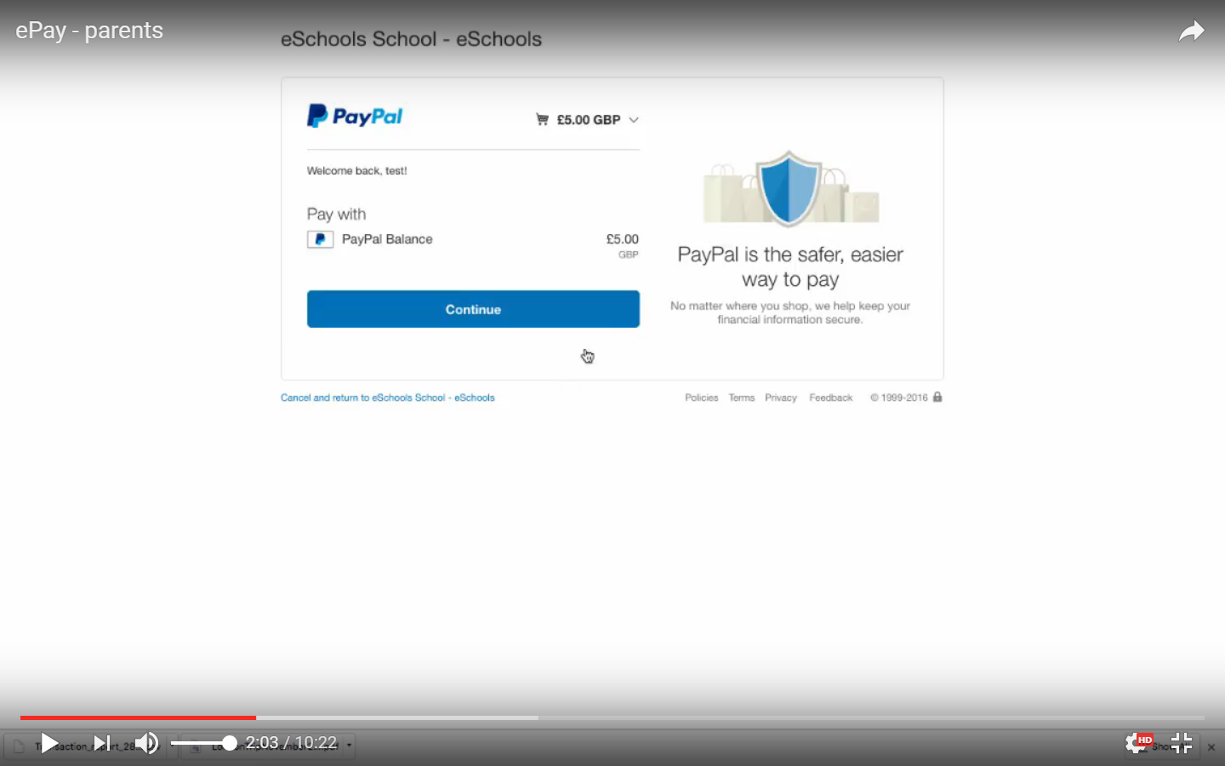

Once you have completed your payment you can return to our VLE by clicking here.

Check and pay as normal.

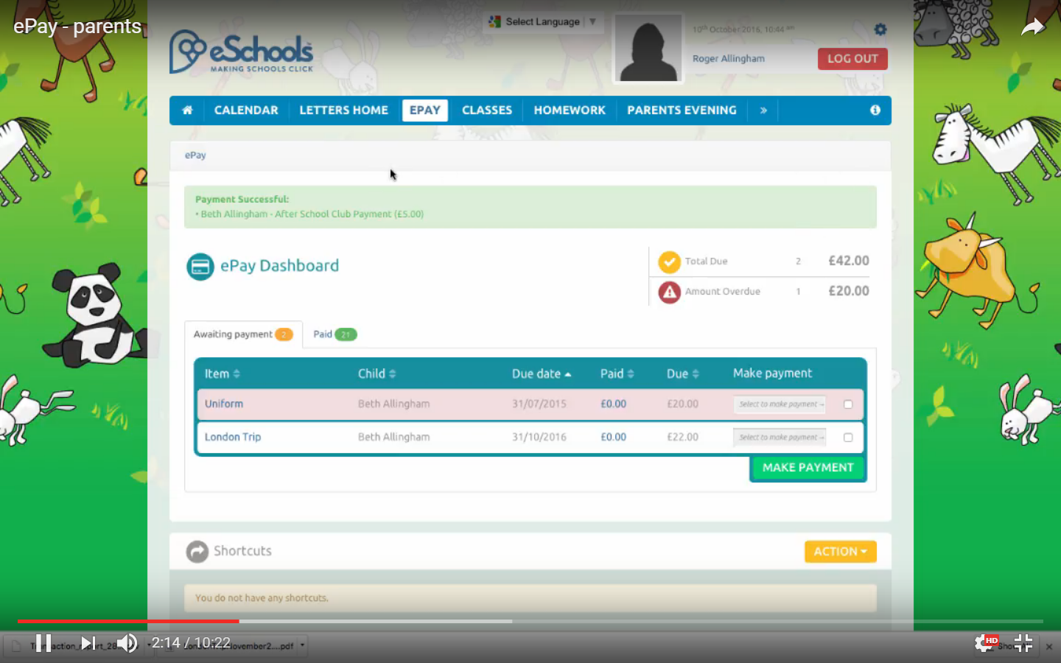

Your payment will no longer show as awaiting payment but can be viewed via the Paid tab (see above).

The payment you have made will be confirmed here.

You will also receive an email from Eschools and one from PayPal.