Curriculum map for Year 4
 | Topic  including.... | Science | ICT | History/ Geography | Art/DT | PE | Music | RSE & PSHE | RE | Extra-Curricular | French English
Year 4  Term 1 | Brainwave – How do I learn?  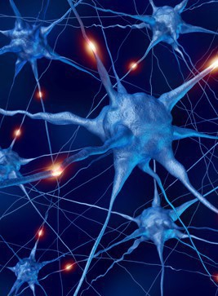 | Animals including humans – food chains, digestive system and teeth.  Understanding more about your body and how to stay healthy | Safe on the Internet  SMART and safe learners  Remember the basics e.g. word processing | Understanding more about the brain and how we learn.  Developing positive mindset to maintain positive learning skills. | Accurate drawings our anatomy  Looking at the various parts f the body.  Prepare healthy foods together. | Invasion Games  Throwing catching - Tag Rugby, Netball  Work with WSP and PE groupings  Whole school tournament | Rhythmic patterns on percussion  Practice for Harvest  Training for becoming Music leaders & WUSU leaders | SEAL - New Beginning  Keeping staying Safe  &  Keeping staying Healthy  Computer Safety | Religious Character  Prepare for becoming a Collective Worship leader with Revd Ainsley  Compare 4 key religions with focus on Sikhism | Forest experience at Longridge  Harvest Festival  Singing for Bray Senior citizens | 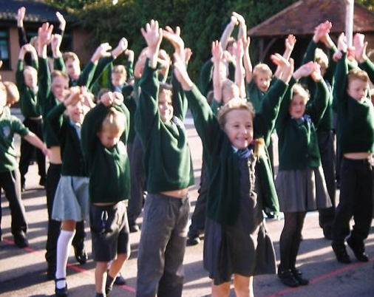  Transition Unit  Leadership on music, CW, sport, EYFS buddies,
Year 4  Term 2 | Egyptians Rule OK!  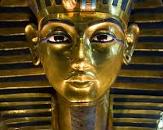 | Electricity  Investigate these simple electrical circuits, switches, buzzers etc.  Design Xmas decoration | Using Search technology  Data Program using Scratch | Egyptians  Famous Egyptian pyramids, Art, inventions, and way of life.  Compare light then and now | Egyptian Art & DT  Recreate Egyptian Art patterns with textiles and sewing shills Create your own tomb wall. | Dance – theme Egyptians  Games – hockey  Work with WSP and PE groupings | Explore composing & songs  Learning music for Egyptians & Christmas Concert | SEAL - Getting on and falling out  Relationship Feelings & Emotions  Bullying | Christianity  What is the Trinity?  Why was light important in religions past and present? | Visit to  Ufton Court  Visit Eton College  Lead the Nativity in Church | Egyptian life  Links to topic including descriptive accounts
Year 4  Term 3 & 4 | I love where I live – Windsor  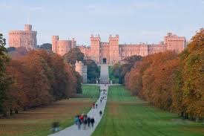 | Sounds  Identify how sounds are made, how sound travels and changes through pitch, volume etc.  Sounds of nature. | Use logical reasoning to explain simple algorithms  Write, debug program  Google Maps | Braywood past and present  Investigate what life would be like in Victorian times | Life studies and still life  Sketches of the local area.  Visit to Fifield with guided tour | Orienteering  Linked to local study  Gym – balance, roll & sequences | Instruments in the orchestra  Steel drums led by Berkshire Maestros  Exploring melodies and scales | SEAL - Going for Goals  &  Good to ne Me  RSE  Being Responsible | Learning about believing  Religious aspect of learning in a C of E school | Easter Concert  Tor of Fifield and talk about local History | Big Write Adventure  Write about life in our local area
Year 4  Term5 & 6 | Chocolate | States of Matter  Compare solid and melting chocolate  Water Cycle | Data collections & Information  Various collection of information | Chocolate  Where and how is chocolate manufactured and how does it find its way to the shops. | Packaging  Design packaging for chocolates and make a chocolate gift. | Cricket, Rounders & Golf Athletics Sports Day  Whole school tournament | Sound / colours  Exploring theme of water cycle  Summer Concert on stage | SEAL Relationship  & Change  RSE  Money Matters | Sharing Faiths  And questioning more about Christianity | Summer Fair  Leavers  PGL Trip  3 days and 2 evenings in activity camp | Poetry and Plays  Play for Summer Concert

