Open Google by searching in the browser

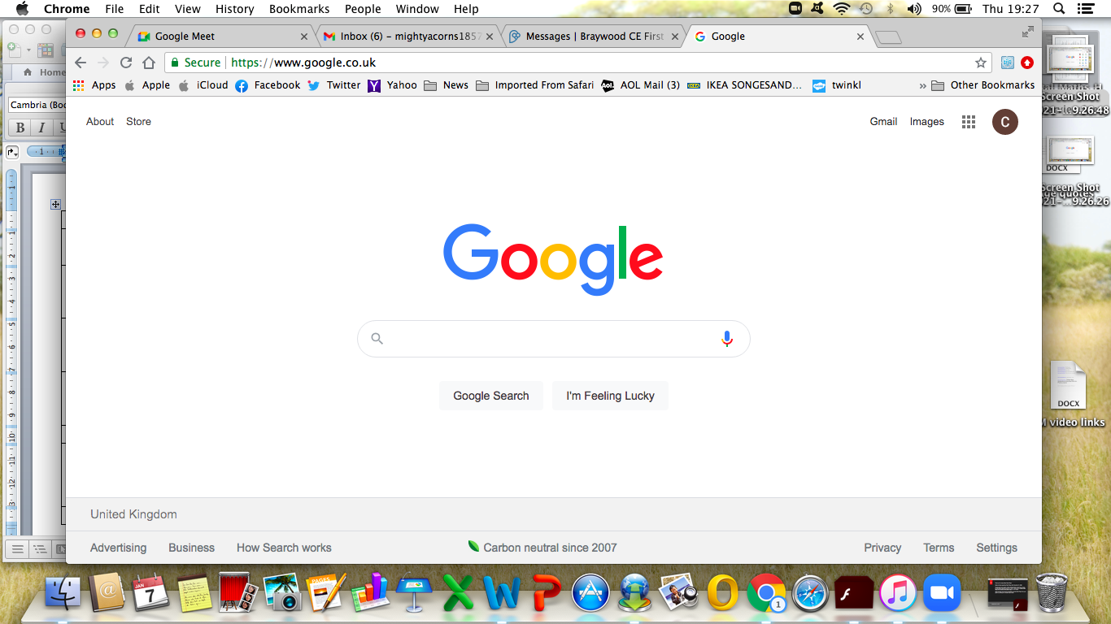

Click on the 9 dots in the top right hand corner to show options and click on “Meet”

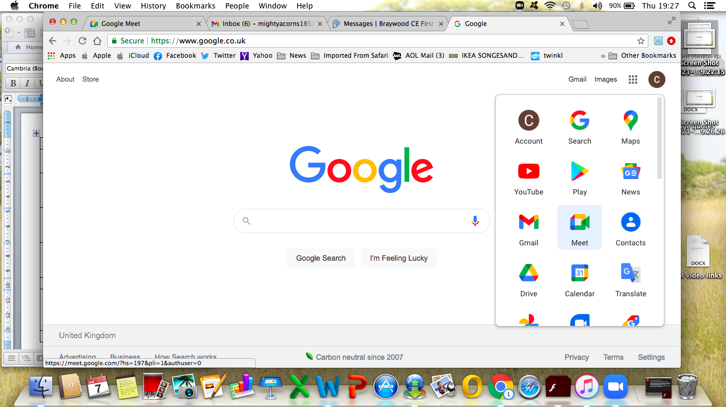

Paste the link you have been sent into “Enter a code or link”

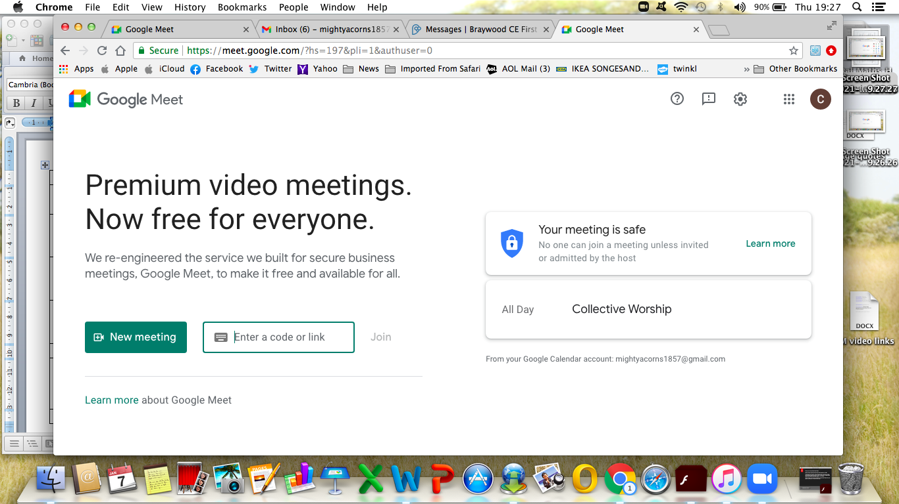
This should take you through to where you are asked to join the meeting. However, some people have found that it takes you through the process of setting up an account, but it is easy to do and free.

